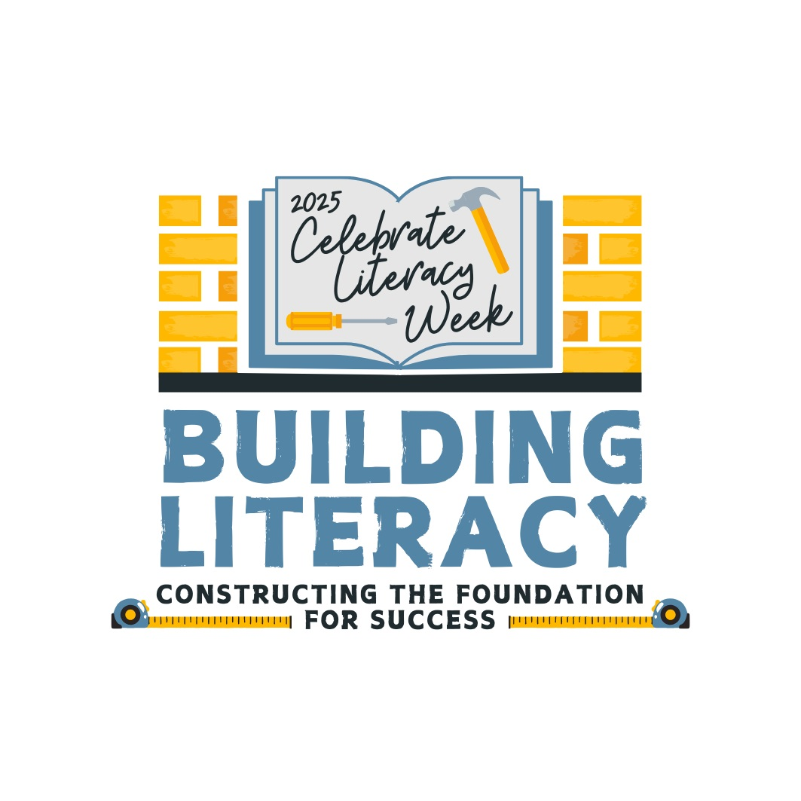

Celebrate Literacy Week, Florida!

January 27-31, 2025

District:

Monday,
January 27th
Tuesday,
January 28th
Wednesday,
January 29th
Thursday,
January 30th
Friday,
January 31st

