CAREER CRUISER | Exploring Local Training Options

Step 3 | Explore postsecondary training.
Driving Question | What are my training options?
Goal | Students will be able to list local training options, including apprenticeship, technical college, state or community college, and university.
Standard | Describe a diversity of postsecondary pathways. (CR.1.3)

FOR TEACHERS

Timeframe | 2 to 4 roughly hour-long lessons.
Materials | Internet and digital device access.
Xello | Xello, Florida’s official K-12 public school career planning and work-based learning coordination system, has tools you can use on this topic! Within the system, navigate to ‘Explore’ and then ‘Schools’ to explore a wide variety of postsecondary training options you can sort, filter, and browse.
Overview | Beginning  - Explain to students that the focus of this lesson will be on understanding local training options. Let students know that they will be allowed to instead research training options distant from their current location, if they so choose.  Middle  - Students will find local training providers (one technical college, one state or community college, one university and one apprenticeship) and learn about the programs they offer.  End  - Have students discuss with a partner how much time they want to spend in training, how far they are willing to move for training, and what programs they are leaning towards.  Extension  - Have students pick two postsecondary training options – a “stretch” goal option that might be hard to get accepted into and a “realistic” goal option that might be easier to gain admission into. Then, have the student write a compare and contrast essay that explains the advantages and disadvantages of the two training options.  - Have students visit GetThereFL.org (a site aimed at raising awareness of Career and Technical Education and Adult Education programs) and/or FloridaShines.org (a site with a wide variety of Florida college and career readiness content). Have the students list three or more postsecondary training providers, a program each offers that is of interest, and one fact that they learned about each institution or program.

FOR STUDENTS

Learn
People that have a “recognized postsecondary credential” (a certificate, certification, degree, or license that business look for or require for certain jobs) are more likely to have a job and more likely to be paid more. Credentials can make a big difference! So, what types of credentials are likely to help your career the most? While it certainly varies across different occupations, there are things that high-quality credentials have in common.

Look for High-Quality Credentials That Are:
- In-Demand
  - Credentials that are “in-demand” are desired by industry and are likely to increase the likelihood of employment and career advancement.
- Aligned to the Your Chosen Career Pathway
  - Since training can cost both time and money, it makes sense to get credentials that are specific to your chosen career pathway.
- “Stackable”
  - A credential is “stackable” when it can articulate credit (get credit for prior learning) to additional, higher credentials. For instance, some career certificate programs can articulate credit to an associate’s degree program, which can articulate credit to a bachelor’s degree program. “Stackability” allows you to enter into and exit from education in a way that recognizes past progress and allows you to step by step advance within a career field.
The below diagram shows how you can “stack” (get credit for prior learning) and add more credentials later on while maintaining the progress you have made already. For instance, a credential from a technical college can be recognized at some state or community colleges, and a credential from a state or community college can significantly shorten the time it takes to get a degree at some universities. 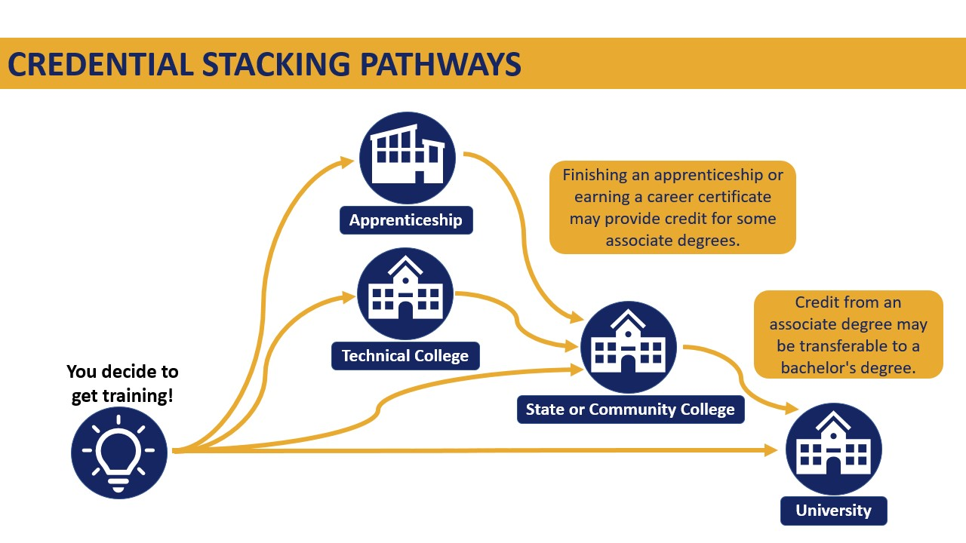
Types of Credentials
The below table has examples of recognized postsecondary credentials.
Credential | Typical Time Commitment | Awarding Institution
Industry-Recognized Certification | Less than a year | Industry Organization or Business
Career Certificate | Less than two years | Technical College or Center
Apprenticeship Certificate of Completion | One to six years | The Florida Department of Education
License | Varies | Varies
Associate Degree | Two years | State or Community College
Bachelor’s Degree | Four years | University or State College
Master’s Degree | Two years | University
Doctorate Degree | Four to six years | University

Do
Identify Your Closest Technical College, State/Community College, and University
- Go to the National Center for Education Statistics’ College Navigator site: https://nces.ed.gov/collegenavigator/.
- Type in your local zip code and then the number of miles away you wish to search for colleges and universities.
- Under ‘Institution Type,’ select ‘<2-Year.' Select ‘Show Results.’ Record in the table below the name of one of the technical colleges listed in the search results. Visit the technical college’s website and record the name of a program you might be interested in. Also, list one thing that stuck out to you on the technical college’s website.
- Under ‘Institution Type,’ select ‘2-Year.' Select ‘Show Results.’ Record in the table below the name of one of the state or community colleges listed in the search results. Visit the state or community college’s website and record the name of a program you might be interested in. Also, list one thing that stuck out to you on the state or community college’s website.
- Under ‘Institution Type,’ select ‘4-Year.' Select ‘Show Results.’ Record in the table below the name of one of the colleges or universities listed in the search results. Visit the college’s or university’s website and record the name of a program you might be interested in. Also, list one thing that stuck out to you on the college’s or university’s website.

Find a Local Apprenticeship
- Go to the U.S. Dept. Of Labor’s Apprenticeship Job Finder at: https://www.apprenticeship.gov/apprenticeship-job-finder.
- Using either the ‘Apprenticeship Jobs’ or ‘Apprenticeship Programs’ tab, leave the occupation field blank (or add in a career you are interested in) and search by your city, state, or zip code.
- Review one or more apprenticeship options locally available.
- Record the name of the employer, the apprenticeship program they offer, and one thing that stuck out to you about the opportunity.

Reflect
Based on your research, complete the below table and answer the questions.
Educational Level | Training Provider/Employer | Program They Offer | Something That Stuck Out to You
< 2-Year
2-Year
4-Year
Apprenticeship
Like: Of the training options you reviewed, which did you like the most? What about them makes you feel that way?
Dislike: Which options did you not like? What about them makes you feel that way?
Learn more: What postsecondary training opportunities would you like to learn more about?

