Florida’s English Language Learner (ELL) Students

Florida’s Number and Growth of ELL Students in Public Schools

Florida’s ELL students are the fastest growing segment of our public school population. Over the past 15 years, the number of ELL students has nearly doubled.

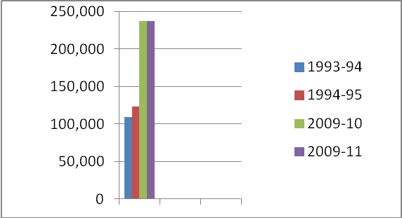

Country of Origin of ELL Students in Florida

Despite common assumptions, native-born U.S. citizens predominate in the ELL student population: 150,973 (58%) are native born to Florida and second or third-generation U.S. citizens.

There are presently 296 different languages identified as native language for students in Florida schools.

Number | Language Name
496,044 | Spanish
63,429 | Haitian-Creole (Includes French Creole)
8,378 | Vietnamese
8,187 | Portuguese
5,993 | Arabic
5,181 | French
5,088 | Chinese, Zhongwen
3,730 | Tagalog
3,238 | Creole
3,173 | Russian
2,390 | Urdu

Florida’s English Language Learner (ELL) Students

Graduation Rate of ELL Students in Florida
NGA rate for ELL = 59.7% (includes standard and special diplomas).
Federal Uniform Rate for ELL = 53.0% (includes only standard diplomas).

Assessment Requirements for ELL Students
Placement assessment to determine eligibility.

The Comprehensive English Language Learning Assessment
The Comprehensive English Language Learning Assessment (CELLA) is a four-skill language proficiency assessment that is designed to provide the following:

- Evidence of program accountability in accordance with Title III of No Child Left Behind (NCLB), which requires schools and districts to meet state accountability objectives for increasing the English language proficiency of ELLs;
- Data for charting student progress over time and for charting the progress of newly-arrived ELLs;
- Information about the language proficiency levels of individual students that may be helpful in making decisions to exit a student from the English for Speakers of Other Languages (ESOL) program; and,
- Diagnostically useful information about individual student’s strengths and weaknesses in English (with as much specificity as possible).

The test items included in this assessment are based on the CELLA proficiency benchmarks, which are aligned to Florida’s English language proficiency standards. All students enrolled in the district (grades K-12) and classified ELL, with a code of “LY” or “LP” must be administered the CELLA. In addition, all students who are coded “LF” on or after September 1 of the current school year must be administered the CELLA.

LY: The student is an English Language Learner and is enrolled in classes specifically designed for English Language Learners.

LF: The student is being followed up for a two-year period after having exited from the ESOL program.

LP: The student is in grades 3-12, tested fully English proficient on an Aural/Oral Test and is an English Language Learner pending the Reading and Writing assessment, or the student is in grades K-12, answered “yes” on the Home Language Survey question “Is a language other than English spoken in the Home?” and is pending aural/oral assessment.

FCAT Reading (2001-2010) and FCAT 2.0 Reading (2011) By Achievement Level
ELL Students Grades 3-10
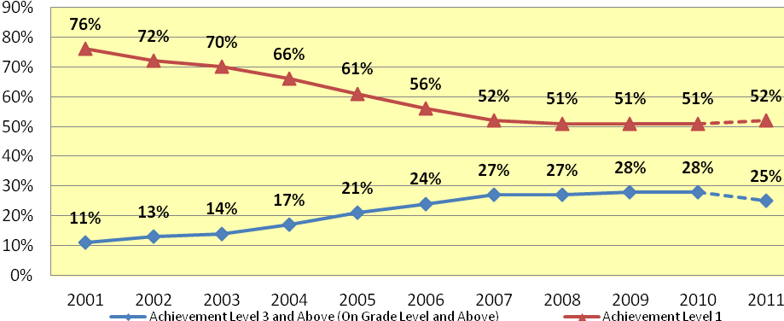
*English Language Learners (ELLs) include students enrolled in classes specifically designed to increase their academic and language proficiency. Source: K20 Education Data Warehouse; Florida Department of Education, June 2011

Outcomes for a 2006-07 ELL Cohort of Students
 |  | Entering in 06-07 | Second Year In School | Third Year In School |  | Fourth Year In School |  | Fifth Year In School
 | Reading Scoring 3 or Above | 16% | 23% | 33% |  | 53% |  | 55%
 | Mathematics  Scoring 3 or Above | 27% | 36% | 45% |  | 63% |  | 65%

ESE Center Schools
Center Schools in Florida | Number | Percentage
Number of ESE Center Schools | 96
Number of ESE Center Schools that are Charter Schools | 23 | 24%
Number of Students Enrolled in Grades 3-12 | 8606
Number and Percent of SWD Enrolled in Grades 3-12 | 8468 | 98%
Primary Disability
Orthopedically Impaired | 157 | 2%
Speech Impaired | 3 | 0%
Language Imparied | 100 | 1%
Deaf/Hard of Hearing | 203 | 2%
Visually Impaired | 150 | 2%
Emotional/Behavioral Disability | 2194 | 26%
Specific Learning Disability | 724 | 9%
Hospital Homebound | 53 | 1%
Dual Sensory Impaired | 10 | 0%
Autism Spectrum Disorder | 1276 | 15%
Traumatic Brain Injured | 53 | 1%
Other Health Impaired | 262 | 3%
Intellectual Disability | 3281 | 39%
Number and Percentage of ELL Students (2 years or more) currently enrolled in ESOL and students who have exited ESOL | 657 | 8%
Number of ELL Students not Included in Accountability (less than 2 years) | 33 | 0%

Students With Disabilities

Population
- In Florida, 352,077 students ages 3-21 are identified as having a disability (October 2011)
  - 39% are identified as specific learning disabled
  - 14% are identified as speech impaired
  - 11% are identified as language impaired
  - 8% are identified as intellectually disabled
  - 6% are identified as emotional/behavior disabled
  - 21% are identified with another disability
- In spring 2011, there were 221,065 students with disabilities in grades 3-10 (tested grades)

Graduation
- More students with disabilities are graduating with a standard diploma
- The percent of students with disabilities graduating with a standard diploma in four years
  - 37.4% in 2005-06
  - 48.7% in 2009-10

Dropouts
- Fewer students with disabilities are dropping out of school
- The percent of students in grades 9-12 dropping out of school
  - 5.4% in 2006-07
  - 3.7% in 2010-11

Least Restrictive Environment
- Students with disabilities are now more likely to be served in settings with their nondisabled peers
- The percent of students with disabilities served by placement setting in 2004-05
  - 49% in a regular class
  - 21% in a resource room
  - 27% in a separate class
  - 2% in a separate school
  - 0.2% in a residential facility
  - 0.6% in a hospital/homebound setting

- The percent of students with disabilities served by placement setting in 2011-12
  - 68% in a regular class
  - 12% in a resource room
  - 17% in a separate class
  - 3% in a separate school
  - 0.2% in a residential facility
  - 0.7% in a hospital/homebound setting
Students With Disabilities

Florida Comprehensive Assessment Test (FCAT)

Between 2008 and 2011, the percent of students with disabilities participating in the FCAT has ranged from 87% to 90%.

Students with disabilities are performing at higher levels on the FCAT.

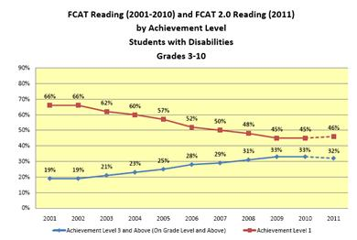
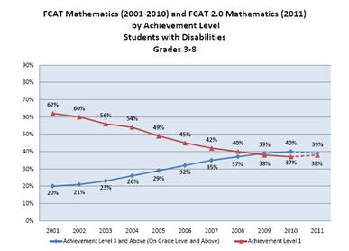

Students With Disabilities

Florida Alternate Assessment (FAA)

Between 2008 and 2011, the percent of students with disabilities participating in the FAA has ranged from 8% to 9%.

Most students taking the FAA are proficient.

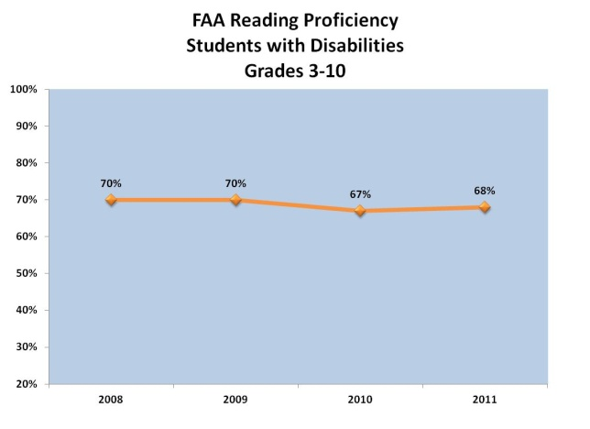

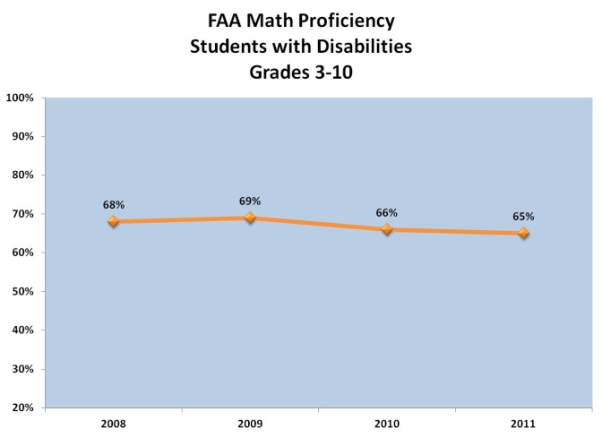

Local Education Agency (LEA) profiles are created annually to provide information about district performance as compared to state level targets in Florida’s State Performance Plan (SPP).

Copies of LEA Profiles may be found at http://www.fldoe.org/ese/datapage.asp.

