2021-24 American Rescue Plan
Elementary and Secondary School Emergency Relief Fund
Liberty- Local Educational Agency ARP ESSER Plan,
Application and Assurances

Liberty – 39

Purpose
Florida must subgrant not less than 90 percent of its total ARP ESSER allocation to local educational agencies (LEAs) (including charter schools that are LEAs) to help meet a wide range of needs arising from the coronavirus pandemic, including reopening schools safely, sustaining their safe operation, and addressing students’ social, emotional, mental health, and academic needs resulting from the pandemic. The State must allocate these funds to LEAs on the basis of their respective shares of funds received under Title I, Part A of the Elementary and Secondary Education Act of 1965 (ESEA) in fiscal year (FY) 2020.

The purpose of this document is to guide districts to plan for the continued implementation of reopening and recovery through the utilization of the 2021-24 ARP ESSER and to assure federal requirements are met. Florida utilized the 2020-21 District Reopening Plan and the Spring 2021 Education Plan to respond to and mitigate the impact of the emergency and to promote the health, safety, and welfare of persons connected with Florida’s educational system.

The Department recognizes that the safe return to in-person instruction must be accompanied by a focus on meeting students’ academic, social, emotional, and mental health needs, and by addressing the opportunity gaps that existed before – and were exacerbated by – the pandemic. In this document, districts will describe how they will support the development of high-quality plans for the use of ARP ESSER funds to achieve these objectives for the following student groups: students from low-income families, from each racial or ethnic background, by gender, English Language Learners, students with disabilities, experiencing homelessness, in foster care, migratory students and other student groups.

Directions
Districts shall submit its ARP ESSER application to the Office of Grants Management via ShareFile on or before November 12, 2021. ShareFile access has been established for the ARP ESSER Lump Sum program for each LEA. The complete application shall include:

- LEA ARP ESSER Plan, Application and Assurances utilizing this template;
- DOE 100A Project Application Form; and
- DOE 101 Budget Narrative Form.

Each LEA developed and made publicly available on the LEA’s website a plan for the safe return of in-person learning in the Fall of 2020. This was before the enactment of the ARP Act. This plan must be updated to address the requirements of the U.S. Department of Education’s Interim Final Rule, 88 FR 21195. The requirements of the Interim Final Rule are summarized in Appendix A. Each LEA shall seek public comment on the updated plan and take such comments into account prior to the submission of the final plan to the Department. Updated plans must comply with state law, including any applicable executive order, any agency emergency action, or any agency regulation or rule. No later than 60 days from receipt of its DOE 200, Project Award Notice, each LEA shall email its updated final plan to recoveryplan@fldoe.org. The subject line of the email must include district name and Plan for the Safe Return of In-person Instruction. Upon the Department’s approval, the LEA shall post this plan on the LEA’s website within 90 days of the award.

Part I: Implementation Plan

The LEA will submit an implementation plan, outlining planned activities for each of the following uses of funds under section 2001(e) of the ARP Act. The description must be adequate to ascertain that the proposed use of funds is necessary to prevent, prepare for, or respond to the COVID-19 pandemic, including its impact on the social, emotional, mental health, and academic needs of students.
Activities should be numbered consecutively. If the LEA does not plan any activities for one or more authorized uses, please indicate that there are no planned activities. School district LEAs shall include the activities identified for charter schools within the LEA, aggregated at the district/LEA level.

Introduction:
Liberty County School District is dedicated to increasing the achievement for each child by ensuring access to rigorous programs, addressing diverse educational needs, and providing access to technology and digital curriculum. The LEA has developed a comprehensive plan to address the learning loss of identified students that is driven by the standards established by the Florida Department of Education and will implement research-based instructional best practices to address learning loss.

Activity 1: Addressing Learning Loss (at least 20% of total allocation). Of the total amount allocated to an LEA, the LEA must reserve at least 20 percent of funds to address learning loss through the implementation of evidence-based interventions such as summer learning or summer enrichment, extended day, comprehensive afterschool programs, or extended school year programs, and ensure that those interventions respond to students’ social, emotional, and academic needs and address the disproportionate impact of COVID-19 on underrepresented student subgroups (each major racial and ethnic group, children from low-income families, children with disabilities, English learners, gender, migrant students, students experiencing homelessness, and children and youth in foster care).

Activity 1, Use of Funds 1: Supplemental Teaching Positions:
The LEA will employ four K-5 teachers at two Title I schools in the district for a period of two school years, 2022-23, and 2023-24. Due to the current academic performance of K-5 students it is necessary to repurpose some classroom teachers as interventionist to address the severe learning loss. This has created fewer teachers that would have resulted in higher class size. These funds are being utilized to provide salaries to replace these teachers. Without these funds these positions would be eliminated, due to current financial conditions, resulting in increased class size at the K-5 level.

Activity 1, Use of Funds 2: Summer Learning
A summer instructional program will be provided for students at Liberty County High School, W. R. Tolar K-8, and Hosford Elementary and Junior High School during the summer of 2021-22, 2022-23, and 2023-24.. This program will address the learning needs of students at risk of retention, students performing below proficiency on state assessments or progress monitoring assessments. The summer program will utilize research-based programs to address identified learning gaps to include the core adopted textbook, SPIRE, Sound Sensible, Reading Rewards, and Edgenuity for credit recovery. The summer program will be held at each school site for a period of 26 days during the months of June and July, four hours per day. The LEA will employ 10 teachers, 3 data entry, 4 paraprofessionals and 5 data scientists to support the implementation of a comprehensive summer learning program. Transportations will be provided as needed for students. Two drivers for up to 26 days during the months of June and July, 3 hours per day, @ hourly rate. This summer learning programs will continue to address gaps in student learning that continue to be evident because of the pandemic.

Activity 1, Use of Funds 3: Extended Day

Extended day learning will be provided to further address learning loss for K-12 students at Liberty County High School, W. R. Tolar K-8, and Hosford Elementary and Junior High School. All students performing below benchmark on progress monitoring assessments and/or those not scoring proficient on state assessments will be invited to participate. Ten teachers will receive $35 per hour for a period of up 50 hours during the 2021-2022 school year, 120 hours during the 2022-23 school year and 100 hours during the 2023-24 school year.
One ELL para, to be paid at the hourly rate of approximately $16.00 per hour, for up to 50 hours during the 2021-2022 school year, 100 hours during the 2022-2023 school year and 100 hours during the 2023-24 school year.

Activity 1, Use of Funds 4: Textbooks

Supplement the purchase of ELA and Mathematics textbooks to facilitate the transition to the B.E.S.T. Standards. This activity will provide research-based core curriculum for all grade levels K-12. The cost of purchasing new ELA and Mathematics textbooks exceeds the district’s allocated funds for textbooks. The LEA will allocate $120,000 to supplement this purchase.

Activity 1, Use of Funds 4: Supplemental Instructional Materials

Research based SPIRE and Sound Sensible to supplemental reading curriculum at $30,000.00 to provide instruction and close learning gaps in K- 3 student population. Other related instructional materials.

Activity 1, Use of Funds 5: Professional Development

The LEA will provide K-12 teachers the opportunity to participate in professional learning to facilitate the transition to the B.E.S.T. ELA and Mathematics standards.
- This will include 2 days at a rate of $125 per day, plus benefits, for face-to-face instruction, for 50 teachers.
- 4 days at a rate of $125 for development of grade level scope and sequence for 6-12 ELA and K-12 mathematics for 43 teachers, for the 2021-22 school year and 20 teachers during the 2022-23 school year.
- Contract services with LSI at a rate of $3,000 per day for a period of 4 days to provide direct instruction for ELA/Math B.E.S.T. standards.

In addition, the LEA will provide ongoing embedded professional learning for both teachers and principals, to address instructional best practices.

- A stipend in the amount of $5,000 will be paid to a retired administrator to provide embedded coaching for principals at all Title I schools for the 2021-22, 2022-23, and 2023-24 school years. The coach will work with all principals, to ensure fidelity of instructional evaluations, and the delivery of quality feedback that increases the likelihood of positive instructional practices in the classroom leading to increase student achievement and closing the achievement gap for struggling students.
- Purchase online professional development modules to support the individualized needs of teachers. These modules will be assigned based on needs that are identified during classroom walk throughs, formal and informal evaluations, with the purpose of increasing teacher effectiveness. This will be an annual contract for the 2022-23 and 2023-24 school years.
- Substitute teachers will be provided for teacher workdays for planning, curriculum alignment, and the review of student data. This will ensure that instruction is tailored to meet the needs of students in an effort to maximize student learning and the instructional practices of teachers. Approximately 30 substitute days, at an average cost of $74 per day.

Activity 2 (A) Any activity authorized by the Elementary and Secondary Education Act of 1965.

- No planned activities

Activity 2 (B), Use of Funds 6: Any activity authorized by the Individuals with Disabilities Education Act.

The LEA will purchase (1) handicap accessible van at an approximate cost of $75,000 to transport medically fragile students. This will accommodate social distancing and provide a safe mode of transportation for SWDs. Note: LEA is seeking pre-approval.

The absence of routines, procedures, and consistent positive interactions due to the pandemic have resulted in an increased need for behavioral and mental health related services. Funds will be utilized to offset the increase cost incurred for contracted behavioral services. The LEA will allocate $50,000.00

Activity 2 (C) Any activity authorized by the Adult Education and Family Literacy Act.

- No Planned Activities

Activity 2 (D), Use of Funds 7: Any activity authorized by the Carl D. Perkins Career and Technical Education Act of 2006.

There is a need to support the salary of the Construction Technology Teacher at Liberty County High School. This is a new position that is currently paid by a legislative appropriation. In the absence of these funds there is not sufficient funding to support the needs of this program, until the program becomes self-sustaining through industry certifications. The salary for one 10-month teacher, to include benefits for the 2022-23 school year and partial salary (62%) for the 2023-24 school year.

There is a need to supplement the purchase of web-based subscriptions for digital tools software, and Microsoft Office. This funding source will also provide the needed funds to implement the use of digital tools at K-8 Title I schools. The implementation of these programs will allow students to earn digital tools certifications and industry certifications.

Activity 2 (E) Coordination of preparedness and response efforts of local educational agencies with State, local, Tribal, and territorial public health departments, and other relevant agencies, to improve coordinated responses among such entities to prevent, prepare for, and respond to coronavirus.

- No Planned Activities

Activity 2 (F) Activities to address the unique needs of low-income children or students, children with disabilities, English learners, racial and ethnic minorities, students experiencing homelessness, and foster care youth, including how outreach and service delivery will meet the needs of each population.

- No Planned Activities

Activity 2 (G) Developing and implementing procedures and systems to improve the preparedness and response efforts of local educational agencies.

- No Planned Activities

Activity 2 (H) Training and professional development for staff of the local educational agency on sanitation and minimizing the spread of infectious diseases.

- No Planned Activities

Activity 2 (I), Use of Funds 8: Purchasing supplies to sanitize and clean the facilities of a local educational agency, including buildings operated by such agency.

The LEA will reimburse sanitation supplies for the 2020-21 school year and purchase additional supplies needed for the 2021-22, and 2023-24 school year, to maintain clean facilities district wide for COVID mitigation, for a total cost of 80,000.00.

Reimburse the cost of one additional custodian for the 2020-21 school year needed to maintain a clean learning environment at Liberty County High School. At a rate of $13,648, salary and benefits. This additional cost will be incurred during the 2021-22 school year.

Activity 2 (J) Planning for, coordinating, and implementing activities during long-term closures, including providing meals to eligible students, providing technology for online learning to all students, providing guidance for carrying out requirements under the Individuals with Disabilities Education Act and ensuring other educational services can continue to be provided consistent with all Federal, State,
and local requirements.

- No Planned Activities

Activity 2(K), Use of Funds 9: Purchasing educational technology (including hardware, software, and connectivity) for students who are served by the local educational agency that aids in regular and substantive educational interaction between students and their classroom instructors, including low-income students and children with disabilities, which may include assistive technology or adaptive equipment.

The LEA will purchase technology related rentals, web-based subscriptions/instructional software and hardware to increase student achievement and close the achievement gap.

Additional software purchases will be made to ensure a safe digital learning environment and the provision of a seamless communication system within the schools/community. This will include the purchase of Server IaaS, Reflex Math, Performance Matters Unify, ParentSquare, BrainPop, Microsoft Office and Canvas, for the 2022-23, and 2023-24 school years.

The district will purchase approximately 240 computers at $500.00 each to support in person and online learning to ensure streamlined learning and reduction of learning loss during the 2022-23, and 2023-24 school year. As well as 5 interactive whiteboards at an approximate cost of $4,000 per device. This is a one-time expenditure.

Three school techs will be employed during the summer for the 2021-22, 2022-23 and 2023-24 school years for the purpose of ensuring that all instructional technology programs are up to date and operational during the summer and at the start of each new school year. This will ensure that instruction is seamless, and no further loss of instructional time is incurred. Techs will work 150 hours during the summer at their hourly rate of pay.

Activity 2(L), Use of Funds 10: Providing mental health services and supports, including through the implementation of evidence-based full-service community schools.

Funds will be expended for two behavioral paraprofessionals to provide behavioral services for identified students, for the 2022-23, and 2023-24 school year. Currently this salary is paid from the Northwest Florida Disaster Grant. These funds will not be renewed in the coming year.

Activity 2(M), Use of Funds 11: Planning and implementing activities related to summer learning and supplemental afterschool programs, including providing classroom instruction or online learning during the summer months and addressing the needs of low-income students, children with disabilities, English learners, migrant students, students experiencing homelessness, and children in foster care.

The LEA will supplement the purchase of virtual instruction for students attending Liberty Virtual (PAEC Franchise and Edgenuity. Partial payment for Florida Virtual School (PAEC Franchise) for 2020-2021, 2021-22, and 2022-2023. The total expenditure for this activity will be approximately $154,485.

Activity 2(N), Use of Funds 12: Addressing learning loss among students, including low-income students, children with disabilities, English learners, racial and ethnic minorities, students experiencing homelessness, and children and youth in foster care, of the local educational agency, including by—
(i) administering and using high-quality assessments that are valid and reliable, to accurately assess students’ academic progress and assist educators in meeting students’ academic needs, including through differentiating instruction;
(ii) implementing evidence-based activities to meet the comprehensive needs of students;
(iii) providing information and assistance to parents and families on how they can effectively support students, including in a distance learning environment; and
(iv) tracking student attendance and improving student engagement in distance education.

The grant will fund two instructional coaches during the 2022-23 and 2023-24 school year, one twelve-month coach and one ten-month coach. These coaching positions are needed to support new teachers, provide embedded professional learning, and build capacity for high quality instructional practices to close identified learning gaps due to school closures and extended quarantines.

Activity 2(O) School facility repairs and improvements to enable operation of schools to reduce risk of virus transmission and exposure to environmental health hazards, and to support student health needs.

- No Planned Activity

Activity 2(P), Use of Funds 13: Inspection, testing, maintenance, repair, replacement, and upgrade projects to improve the indoor air quality in school facilities, including mechanical and nonmechanical heating, ventilation, and air conditioning systems, filtering, purification and other air cleaning, fans, control systems, and window and door repair and replacement.

The LEA will purchase HVAC units at Tolar school to improve the indoor air quality, ventilation, air conditioning systems, and filtering within the school. For the 2021-22 and the 2022-23 school year we will purchase 10 units @ approximately $10,000 per units per year. This will assist in the reduction of the spread of infectious diseases by improving air quality.

Activity 2(Q) Developing strategies and implementing public health protocols including, to the greatest extent possible and not inconsistent with state law, policies in line with guidance from the Centers for Disease Control and Prevention for the reopening and operation of school facilities to effectively maintain the health and safety of students, educators, and other staff.

- No Planned Activity

Activity 2(R), Use of Funds 14: Other activities that are necessary to maintain the operation of and continuity of services in local educational agencies and continuing to employ existing staff of the local educational agency.

Non-instructional and instructional full-time employees that did not receive bonus compensation through the CARES Act First Responders allocation will receive a matching bonus. The incurred cost will be $1,083, for 94 eligible employees for the 2021-2022 school year, at a total cost of $101,802, plus benefits.

Activity 2 (S), Use of Funds 15: Administration. LEAs may take reasonable and necessary administrative costs, to include direct and indirect costs. Indirect costs may be taken up to the negotiated, unrestricted indirect cost rate. However, to ensure that the total administrative costs are reasonable, the total direct and indirect costs may not exceed five percent (5%) of the LEA’s total award.

Indirect cost at 5%.

Part II: Ensuring Effectiveness of Interventions

Please describe how the LEA will ensure that the interventions it implements, including but not limited to the interventions under section 2001(e)(1) of the ARP Act to address the academic impact of lost instructional time, will respond to the academic, social, emotional, and mental health needs of all students, and particularly those students disproportionately impacted by the COVID-19 pandemic, including students from low-income families, students of color, English learners, children with disabilities, students experiencing homelessness, children and youth in foster care, and migratory students. In your response, please include a description of interventions and strategies that are aligned to the LEA’s data (disaggregated by subgroup), and describe how the LEA will measure the effectiveness of the selected interventions.

Liberty County School District will ensure that the interventions implemented utilizing ARP funds will address the academic, social, emotional, and mental health needs of all students, paying particular attention to those students disproportionally impacted by the COVID -19 pandemic, specifically students from low-income families, students of color, English learners, children with disabilities, students experiencing homelessness, children and youth in foster care, and migratory students. Below is the outline for LCSD’s ELA, Math, and Science data, disaggregated by subgroup, based on this data the LEA has outlined strategies to address the unique needs of each targeted population. The following data collection methods will be utilized to ensure fidelity of implementation. Ongoing progress monitoring will take place over the timeframe of the grant implementation cycle to ensure that all strategies are yielding the desired results.
- Progress monitoring data for all targeted students
- Staff and student sign-in sheets for all extended day and summer programs
- Lesson plan submissions for extended day and summer programs
- Mental health documentation
- Coaching impact data collection
- Documentation of reduced COVID breakouts as a result of increased cleanliness and air circulation

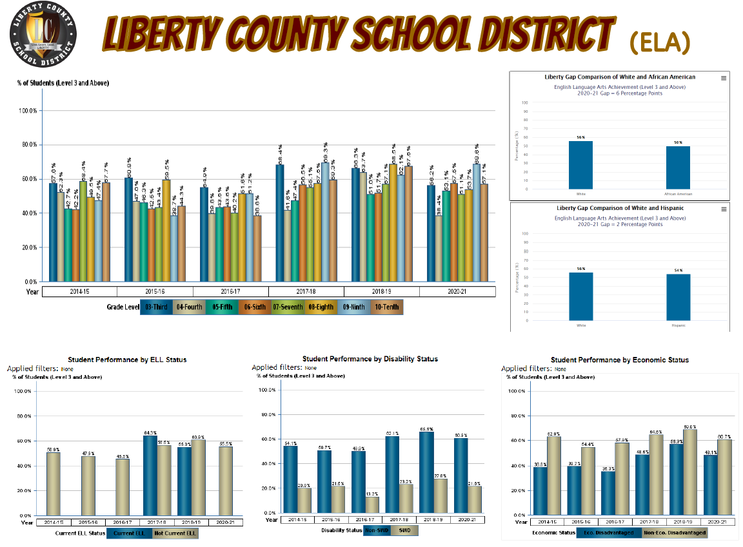
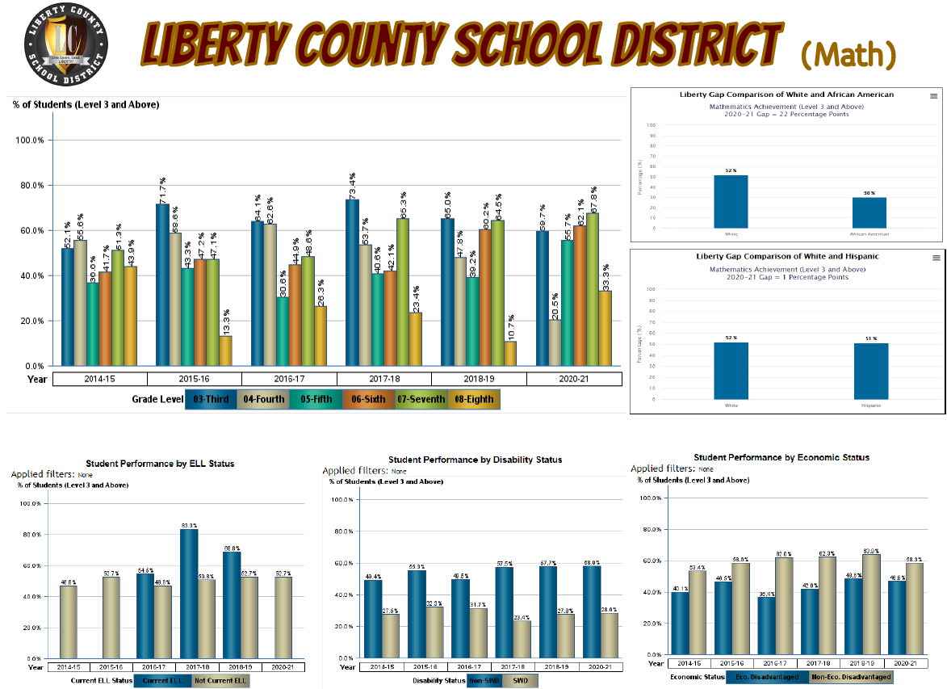

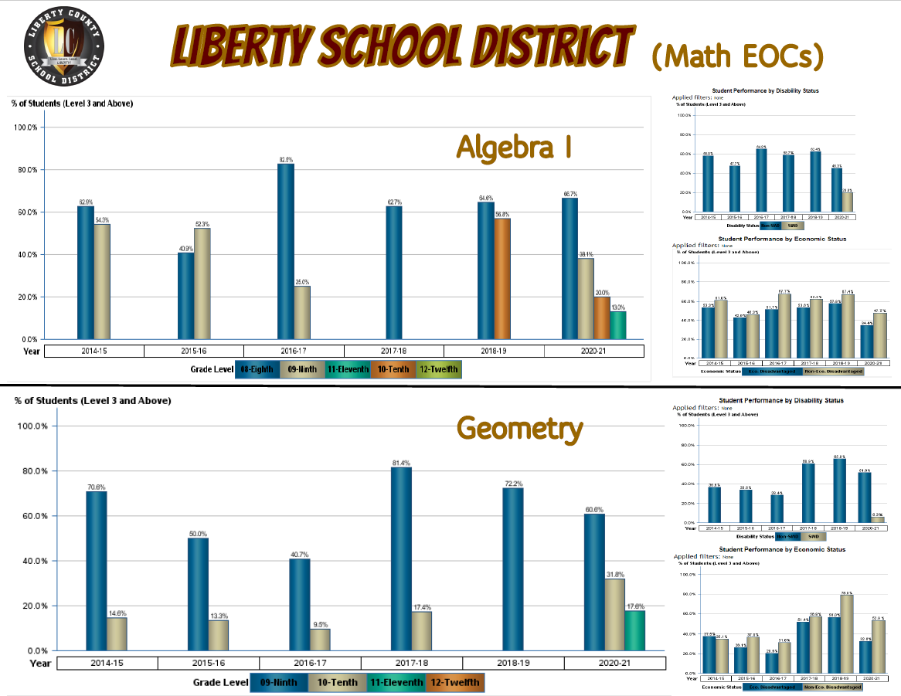

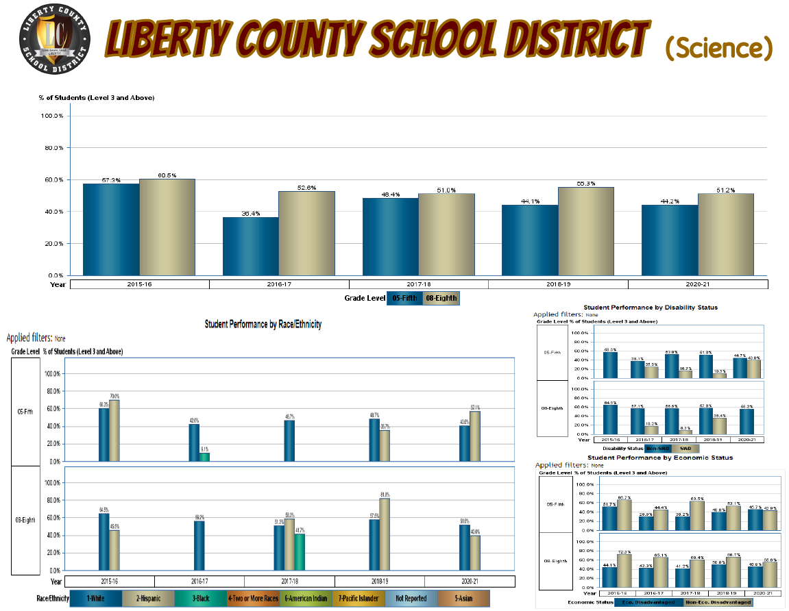

Part III LEA Plan for Safe Return of In-Person Instruction

Each LEA developed and made publicly available on the LEA’s website a plan for the safe return of in-person learning in the Fall of 2020. This was before the enactment of the ARP Act. This plan must be updated to address the requirements of the U.S. Department of Education’s Interim Final Rule, 88 FR 21195. The Interim Final Rule “does not mandate that an LEA adopt the CDC guidance, but only requires that the LEA describe in its plan the extent to which it has adopted the key prevention and mitigation strategies identified in the guidance.” 88 FR at 21200. Any updated LEA plan must be consistent with state law, including any applicable executive order, any agency emergency order, or any agency regulation or rule. Note specifically that LEA policies must comply with section 381.00316, Florida Statutes, and that any policies implemented after August 9, 2021 must comply with Florida Department of Health Rule 64DER21 -12, F.A.C., and any policies implemented after September 22, 2021 must comply with Florida Department of Health Rule 64DER21-15, F.A.C.

Each LEA must seek public comment on the plan and take such comments into account prior to submission of the final plan to the Department within 60 days of the award. Upon the Department’s approval, the LEA shall post this updated plan on the LEA’s website within 90 days of the award.

☒ By checking this box, the LEA acknowledges the requirement that each LEA shall update its Plan for Safe Return of In-Person Instruction to reflect the requirements stated above, shall seek public comment on the updated plan and take such comments into account prior to the submission of the final plan to the Department within 60 days of the award. Upon the Department’s approval, the LEA shall post this updated plan on the LEA’s website within 90 days of the award.

Part IV: Assurances

The district must agree to ALL of the assurances by checking the corresponding boxes.

☒ Assurance 1: LEA Periodic Plan Update with Public Comment. As required in the U.S. Department of Education’s Interim Final Rule, 88 FR 21195, the LEA must regularly, but no less frequently than every six months, review and as appropriate, revise its plan for the safe return to in-person instruction and continuity of services. In determining whether revisions are necessary, and in making any revisions, the LEA must seek public input and take such input into account. If at the time the LEA revises its plan the CDC has updated its guidance on reopening schools, the revised plan must address the extent to which the LEA has adopted policies, and describe any policies, for each of the updated safety recommendations. Significantly, the Interim Final Rule “does not mandate that an LEA adopt the CDC guidance, but only requires that the LEA describe in its plan the extent to which it has adopted the key prevention and mitigation strategies identified in the guidance.” 88 FR at 21200. Any updated LEA plan must be consistent with state law, including any applicable executive order, any agency emergency order, or any agency regulation or rule. Specifically, LEA policies must comply with section 381.00316, Florida Statutes, and any policies implemented after August 9, 2021 must comply with Florida Department of Health Rule 64DER21 -12, F.A.C., and any policies implemented after September 22, 2021 must comply with Florida Department of Health Rule 64DER21-15, F.A.C.
☒ Assurance 2: Continue progress monitoring and interventions. The district agrees to provide robust progress monitoring and requisite interventions must be extended to all students with tiered support for students who are performing below grade level and are not making adequate progress. Students who are receiving instruction through innovative teaching methods must transition to another teaching method if they fail to make adequate progress. The district agrees to provide monthly progress monitoring reports to parent/guardians for students identified as performing below grade level and/or demonstrating decline on the district’s progress monitoring system.

☒ Assurance 3: Allowable Uses of Funds. The LEA will use funds for activities allowable under section 2001(e) of the CRRSA Act.

☒ Assurance 4: Maintenance of Equity. The LEA will comply with all requirements relating to Maintenance of Equity, in accordance with section 2004(c) of the ARP Act.

☒ Assurance 5: Reporting. The LEA will comply with all reporting requirements, and submit required reports to the Florida Department of Education at such time and in such manner and containing such information as the department may subsequently require.

☒ Assurance 6: Audits, Inspections or Examinations. The LEA will cooperate with any examination of records with respect to such funds by making records available for inspection, production, and examination, and authorized individuals available for interview and examination, upon the request of (i) the Florida Department of Education, the Florida Auditor General; (ii) the Department and/or its Inspector General; or (iii) any other federal or state agency, commission, or department in the lawful exercise of its jurisdiction and authority.

Acknowledgement

Local Educational Agency Chief Executive Officer or Authorized Representative

Name and title of person responsible for completion and submission
Gay Lewis, Director of Instruction
Contact information: email, phone number
Gay.lewis@lcsb.org, 850-643-2275 EX11233
Superintendent signature (or authorized representative)

