2021-24 American Rescue Plan
Elementary and Secondary School Emergency Relief Fund
Local Educational Agency ARP ESSER Plan,
Application and Assurances

Gilchrist County School District - 210

Purpose
Florida must subgrant not less than 90 percent of its total ARP ESSER allocation to local educational agencies (LEAs) (including charter schools that are LEAs) to help meet a wide range of needs arising from the coronavirus pandemic, including reopening schools safely, sustaining their safe operation, and addressing students’ social, emotional, mental health, and academic needs resulting from the pandemic. The State must allocate these funds to LEAs on the basis of their respective shares of funds received under Title I, Part A of the Elementary and Secondary Education Act of 1965 (ESEA) in fiscal year (FY) 2020.

The purpose of this document is to guide districts to plan for the continued implementation of reopening and recovery through the utilization of the 2021-24 ARP ESSER and to assure federal requirements are met. Florida utilized the 2020-21 District Reopening Plan and the Spring 2021 Education Plan to respond to and mitigate the impact of the emergency and to promote the health, safety, and welfare of persons connected with Florida’s educational system.

The Department recognizes that the safe return to in-person instruction must be accompanied by a focus on meeting students’ academic, social, emotional, and mental health needs, and by addressing the opportunity gaps that existed before – and were exacerbated by – the pandemic. In this document, districts will describe how they will support the development of high-quality plans for the use of ARP ESSER funds to achieve these objectives for the following student groups: students from low-income families, from each racial or ethnic background, by gender, English Language Learners, students with disabilities, experiencing homelessness, in foster care, migratory students and other student groups.

Directions
Districts shall submit its ARP ESSER application to the Office of Grants Management via ShareFile on or before November 12, 2021. ShareFile access has been established for the ARP ESSER Lump Sum program for each LEA. The complete application shall include:

- LEA ARP ESSER Plan, Application and Assurances utilizing this template;
- DOE 100A Project Application Form; and
- DOE 101 Budget Narrative Form.

Each LEA developed and made publicly available on the LEA’s website a plan for the safe return of in-person learning in the Fall of 2020. This was before the enactment of the ARP Act. This plan must be updated to address the requirements of the U.S. Department of Education’s Interim Final Rule, 88 FR 21195. The requirements of the Interim Final Rule are summarized in Appendix A. Each LEA shall seek public comment on the updated plan and take such comments into account prior to the submission of the final plan to the Department. Updated plans must comply with state law, including any applicable executive order, any agency emergency action, or any agency regulation or rule. No later than 60 days from receipt of its DOE 200, Project Award Notice, each LEA shall email its updated final plan to recoveryplan@fldoe.org. The subject line of the email must include district name and Plan for the Safe Return of In-person Instruction. Upon the Department’s approval, the LEA shall post this plan on the LEA’s website within 90 days of the award.

Part I: Implementation Plan

The LEA will submit an implementation plan, outlining planned activities for each of the following uses of funds under section 2001(e) of the ARP Act. The description must be adequate to ascertain that the proposed use of funds is necessary to prevent, prepare for, or respond to the COVID-19 pandemic, including its impact on the social, emotional, mental health, and academic needs of students.
Activities should be numbered consecutively. If the LEA does not plan any activities for one or more authorized uses, please indicate that there are no planned activities. School district LEAs shall include the activities identified for charter schools within the LEA, aggregated at the district/LEA level.

Activity 1: Addressing Learning Loss (at least 20% of total allocation). Of the total amount allocated to an LEA, the LEA must reserve at least 20 percent of funds to address learning loss through the implementation of evidence-based interventions such as summer learning or summer enrichment, extended day, comprehensive afterschool programs, or extended school year programs, and ensure that those interventions respond to students’ social, emotional, and academic needs and address the disproportionate impact of COVID-19 on underrepresented student subgroups (each major racial and ethnic group, children from low-income families, children with disabilities, English learners, gender, migrant students, students experiencing homelessness, and children and youth in foster care).

Learning loss for Gilchrist County Schools due to COVID related absences and school closures would be addressed through the hiring of 2 school interventionists for each campus. This would be a total of 8 additional teachers who would support students as follows: Two interventionists on each K-5 campus (total of 4) and two interventionists on each 6-12 campus (total of 4). The purpose of this staff is to use current and relevant student data to close the learning gap for identified students which include all subgroups such as ELL, ESE, 504, Homeless and unaccompanied youth as well as ethnic groups who have had a disproportionate impact on their education. Interventionists are certified teachers who are trained in data-driven best practices to support students through the RTI process. Supplemental curriculum will also be purchased to facilitate the additional interventionists brought on board in addressing the identified learning loss areas.

Activity 2 (A) Any activity authorized by the Elementary and Secondary Education Act of 1965.

Gilchrist County Schools has a comprehensive and robust professional development plan to support teacher, administrative, and overall staff growth and pedagogy. Through this plan, we work to ensure understanding and implementation of standards-based instruction, and social and emotional student needs. However, this plan was severely interrupted by early COVID-19 closures and subsequent capacity limitations and travel restrictions. With ARP funds we intend to reimplement these trainings to keep our teachers prepared for the disparate educational impacts of COVID-19. Cost associated with professional development includes trainers, consultants, materials, travel, substitutes, and registration fees. Examples of anticipated trainings include: Maxwell Group Leadership Training, AVID, updated FL Standards training, ICP, and school reopening training.

Activity 2 (B) Any activity authorized by the Individuals with Disabilities Education Act.

No Planned Activities

Activity 2 (C) Any activity authorized by the Adult Education and Family Literacy Act.

No Planned Activities

Activity 2 (D) Any activity authorized by the Carl D. Perkins Career and Technical Education Act of 2006.

No Planned Activities

Activity 2 (E) Coordination of preparedness and response efforts of local educational agencies with State, local, Tribal, and territorial public health departments, and other relevant agencies, to improve coordinated responses among such entities to prevent, prepare for, and respond to coronavirus.

No Planned Activities

Activity 2 (F) Activities to address the unique needs of low-income children or students, children with disabilities, English learners, racial and ethnic minorities, students experiencing homelessness, and foster care youth, including how outreach and service delivery will meet the needs of each population.

No Planned Activities

Activity 2 (G) Developing and implementing procedures and systems to improve the preparedness and response efforts of local educational agencies.

No Planned Activities

Activity 2 (H) Training and professional development for staff of the local educational agency on sanitation and minimizing the spread of infectious diseases.

No Planned Activities

Activity 2 (I) Purchasing supplies to sanitize and clean the facilities of a local educational agency, including buildings operated by such agency.

No Planned Activities

Activity 2 (J) Planning for, coordinating, and implementing activities during long-term closures, including providing meals to eligible students, providing technology for online learning to all students, providing guidance for carrying out requirements under the Individuals with Disabilities Education Act and ensuring other educational services can continue to be provided consistent with all Federal, State,
and local requirements.

No Planned Activities

Activity 2(K) Purchasing educational technology (including hardware, software, and connectivity) for students who are served by the local educational agency that aids in regular and substantive educational interaction between students and their classroom instructors, including low-income students and children with disabilities, which may include assistive technology or adaptive equipment.

Gilchrist County places an emphasis on technology to support the students access to current educational material through the purchase of interactive panels for classrooms, and new computer hardware for our computer labs. The interactive panels allow students to access cutting edge material, lessons, and an overall strong learning curriculum aiding our teachers and interventionists to address learning gaps as identified through our ICP plan in our low-income, disabled, and underrepresented groups created by COVID-19 closures. The computer hardware will serve to upgrade existing setups with more up-to-date technology and connectivity. This will assist in addressing the before mentioned learning gaps, as well as ensuring teachers have a more secure, reliable connection with their students and curriculum should school closures need to occur again.

Activity 2(L) Providing mental health services and supports, including through the implementation of evidence-based full-service community schools.

No Planned Activities

Activity 2(M) Planning and implementing activities related to summer learning and supplemental afterschool programs, including providing classroom instruction or online learning during the summer months and addressing the needs of low-income students, children with disabilities, English learners, migrant students, students experiencing homelessness, and children in foster care.

As detailed in our ICP plan, Gilchrist County schools would offer afterschool tutors and summer reading coaches (K-5) at all our campuses to help address identified learning gaps for our low-income, disabled, English learners, migrant, foster, and homeless students who were disparately impacted by COVID-19 closures. This would cover the cost of said tutor and reading coach salaries as well as associated benefits.

Activity 2(N) Addressing learning loss among students, including low-income students, children with disabilities, English learners, racial and ethnic minorities, students experiencing homelessness, and children and youth in foster care, of the local educational agency, including by—
(i) administering and using high-quality assessments that are valid and reliable, to accurately assess students’ academic progress and assist educators in meeting students’ academic needs, including through differentiating instruction;
(ii) implementing evidence-based activities to meet the comprehensive needs of students;
(iii) providing information and assistance to parents and families on how they can effectively support students, including in a distance learning environment; and
(iv) tracking student attendance and improving student engagement in distance education.

No Planned Activities

Activity 2(O) School facility repairs and improvements to enable operation of schools to reduce risk of virus transmission and exposure to environmental health hazards, and to support student health needs.

Gilchrist County Schools would like to implement improvements to three existing buildings and repair existing furniture in order to reduce our District Office and school campuses risk of virus transmission and exposure. This would also update our existing facilities to current environmental health standards which have altered since the start of the pandemic.

Two of the three buildings requested for facilities improvement are our District Offices and County Office Annex. The requested improvements would include: restructuring the internal layouts, repair/replace flooring, addressing air quality repairs, roof repairs, paint, existing furniture repair, mats for directing social distancing, and cleaning. These improvements would increase our number of available offices, allowing us to further comply with CDC COVID-19 social distancing recommendations for office spaces (https://www.cdc.gov/coronavirus/2019-ncov/community/office-buildings.html ). Current layouts hold two employees or more per office, with forward facing desk orientations, with poor ventilation and foot traffic control which increases the risk of viral transmission amongst employees. The improvements to the County Office Annex would also offer the ability to expand our Mental Health department, allowing Gilchrist to expand our Mental Health offerings to our impacted students such as those in ESE, ELL, ESOL, 6-12, and lower-income demographics, by granting additional offices, therapy rooms, and lab spaces.

The third building requested for improvements would be our gym. The requested improvements would include: flooring repair, addressing seating layouts, air quality repair, and roof repairs. These improvements would enable us to expand the use of the gym to help accommodate social distancing and other COVID-19 requirements as well as bring it up to code on current environmental health standards. This would give us an additional space to support student mental and physical health which was has been negatively impacted by local quarantine and closure measures via physical activity offerings.

All building repairs would include touchless controlled entry systems. Due to the Covid pandemic, the goal of Gilchrist Schools is to implement health a safety measures to reduce touchable surfaces by multiple people. These facilities have multiple entry and exit routes and the touchless systems will support traffic patterns by allowing specific doors to be controlled remotely. This will also reduce surface contact transmission and foot traffic tracing for possible viral transmission in conjunction with our local Health Department. This would increase the safety of both students and employees as well as give many in our school’s better mental wellbeing during these unprecedented times.

In the 2021 school year, all schools in Florida temporarily closed at some point during the COVID-19 pandemic. In addition to the initial closures, there were varying reopening timelines. As schools reopen however, reopening doesn’t always mean back to business as usual. There is a need to deliver a consistent message to families and all stakeholders in communicating new and current guidelines, potential closures, health updates and requirements in real time. Schools serve thousands of students and the community as a whole and need signage to help their employees and students follow new requirements and guidelines. Digital displays are needed as a front-line option of communication for coronavirus signage because they are versatile, adaptable, and timely. These signs can display capacity limits, mask mandates and requirements, directional information and traffic patterns, safety and health information and reminders as well as closure information.

Activity 2(P) Inspection, testing, maintenance, repair, replacement, and upgrade projects to improve the indoor air quality in school facilities, including mechanical and nonmechanical heating, ventilation, and air conditioning systems, filtering, purification and other air cleaning, fans, control systems, and window and door repair and replacement.

As stated in Activity 2(o), those same buildings will need HVAC upgrades or replacement to support quality air for those who use the facility. Current HVAC systems are outdated and do not fully comply with quality standards and appropriate filtration recommended for COVID-19 reduction. The buildings currently are minimally used due to this concern for student and staff health. These improvements would enable the District fully utilize these facilities increasing office space, therapy rooms, and lab availabilities.

Activity 2(Q) Developing strategies and implementing public health protocols including, to the greatest extent possible and not inconsistent with state law, policies in line with guidance from the Centers for Disease Control and Prevention for the reopening and operation of school facilities to effectively maintain the health and safety of students, educators, and other staff.

Taking CDC Post-COVID-19 Conditions (https://www.cdc.gov/coronavirus/2019-ncov/long-term-effects/index.html ) which can affect breathing and heart health into account, Gilchrist County will purchase AED machines, provide training with the machines, and additional first aid responses. This is to ensure our educators and staff are knowledgeable of possible post-COVID-19 conditions, know how to handle them appropriately, and have up-to-date equipment for what could be a lifesaving response as students, educators, and staff return to campus.
Schools play critical roles in promoting equity in learning and health, particularly for groups disproportionately affected by COVID-19. Students living in rural areas, students with disabilities, have been disproportionately affected by COVID-19. For these reasons, health equity considerations related to the K-12 setting are a critical part of decision-making and have been considered in CDC’s updated guidance for schools. Gilchrist County is growing and transportation of students is an area where social distancing has become a challenge. The district will purchase 2 school busses to alleviate overcrowded busses and support social distancing of students in compliance with Covid health updates. Along with regular bus duties, these busses will provide transportation to students outside of the school day to support learning loss by offering transportation from after school activities. Busses can also be utilized for delivery of food to students in rural areas and offering extended bus routes for students.

Activity 2(R) Other activities that are necessary to maintain the operation of and continuity of services in local educational agencies and continuing to employ existing staff of the local educational agency.

Governor DeSantis has supported educational employees by allowing for one-time bonuses for those working through the pandemic, however this was focused on educators alone. Gilchrist County Schools will expand on this by providing a one-time bonus of $1,000 to employees who were omitted by category from the initial bonus, promoting equity among our employees and aiding those who were excluded but also expected to work through mandated closures. This would include Assistant Principals, Directors, Literacy Coaches and other administrative staff as well as non-teachers such as paraprofessionals, maintenance, cafeteria and clerical employees. This will ensure continuity of their vital services which support educators and our student body through equitable treatment and inclusion.

Activity 2 (S) Administration. LEAs may take reasonable and necessary administrative costs, to include direct and indirect costs. Indirect costs may be taken up to the negotiated, unrestricted indirect cost rate. However, to ensure that the total administrative costs are reasonable, the total direct and indirect costs may not exceed five percent (5%) of the LEA’s total award.

Indirect Cost will be taken at 5%.

Part II: Ensuring Effectiveness of Interventions

Please describe how the LEA will ensure that the interventions it implements, including but not limited to the interventions under section 2001(e)(1) of the ARP Act to address the academic impact of lost instructional time, will respond to the academic, social, emotional, and mental health needs of all students, and particularly those students disproportionately impacted by the COVID-19 pandemic, including students from low-income families, students of color, English learners, children with disabilities, students experiencing homelessness, children and youth in foster care, and migratory students. In your response, please include a description of interventions and strategies that are aligned to the LEA’s data (disaggregated by subgroup), and describe how the LEA will measure the effectiveness of the selected interventions.

Gilchrist County School district has and will continue to work toward the use of ESSER funds to make student achievement its number one priority. Through the leveraging of personnel, students of all groups will have access to high quality interventions based on their individualized needs. The district has a robust Multi-Tiered System of supports for all students Kindergarten thru 12th grade. This is all inclusive to ELL, ESE, 504, Foster, truant and Homeless students as well as any student who has felt a disparity due to the Covid-19 pandemic. School based staff keep records of scope, frequency as well as progress monitoring of students who receive a variety of interventions and supports. School based and district level teams also meet regularly to ensure student data, identification, and response to Intervention is monitored, and discussed. Action plans are created for students as needed and students flow through the tiers fluidly as needed. Literacy Coaches and administrative teams also complete walk through’s during intervention time to ensure fidelity of implementation. Trends are analyzed and feedback is given. Given that Gilchrist County has current FSA data to use as a baseline, achievement of interventions will be shown through FSA achievement levels annually in reading and math. Regarding social and emotional needs of students, we have expanded this department to support students. The use of survey data and discipline data is used to identify trends and assist schools and families in supporting their student.

Gilchrist County Student Data:
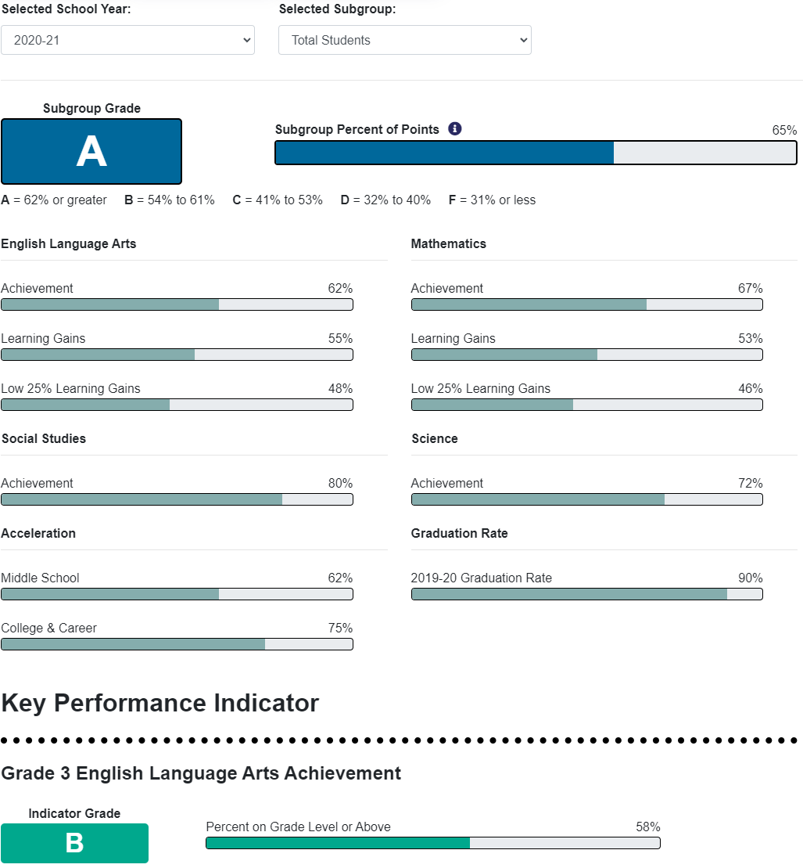

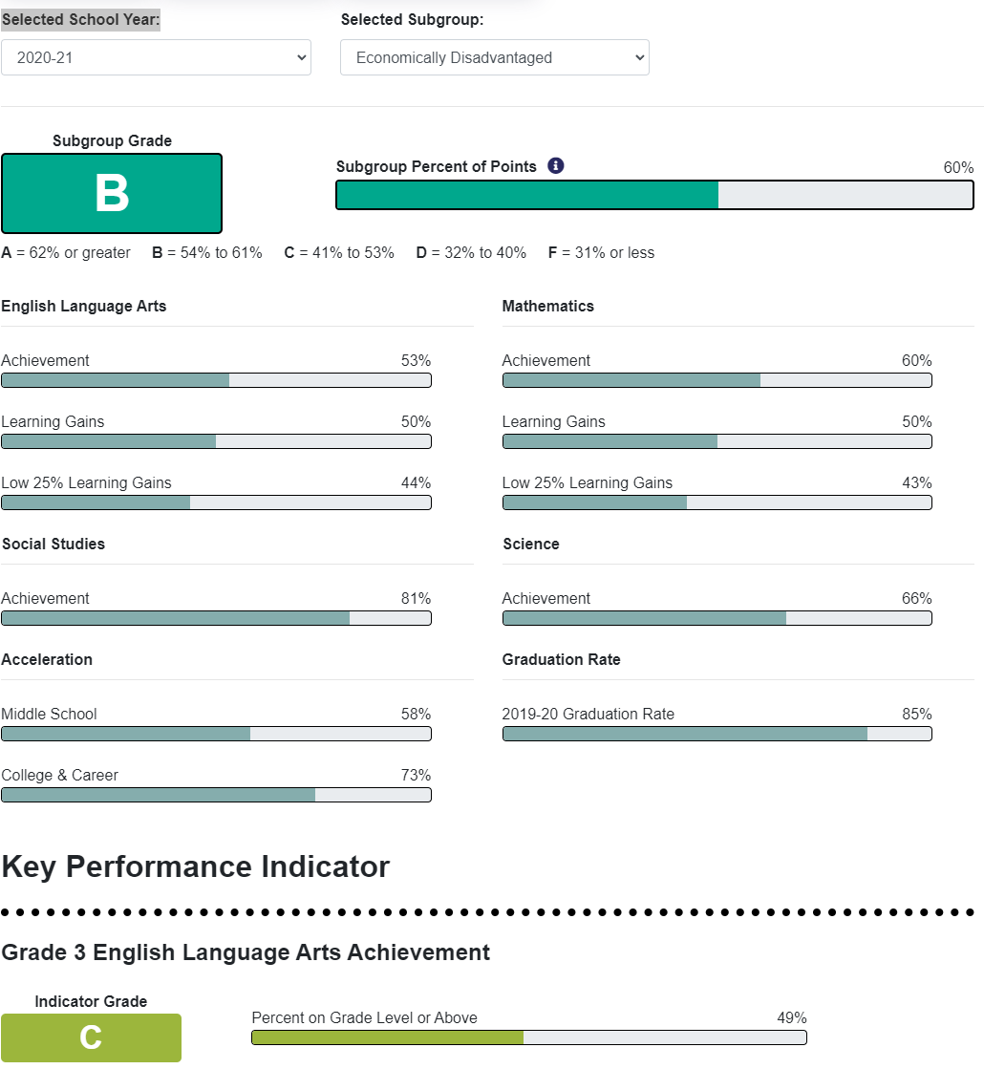
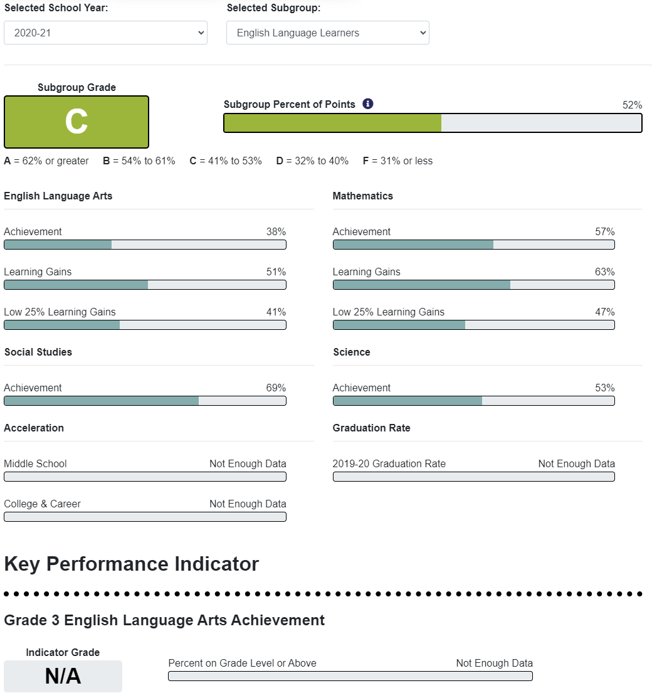
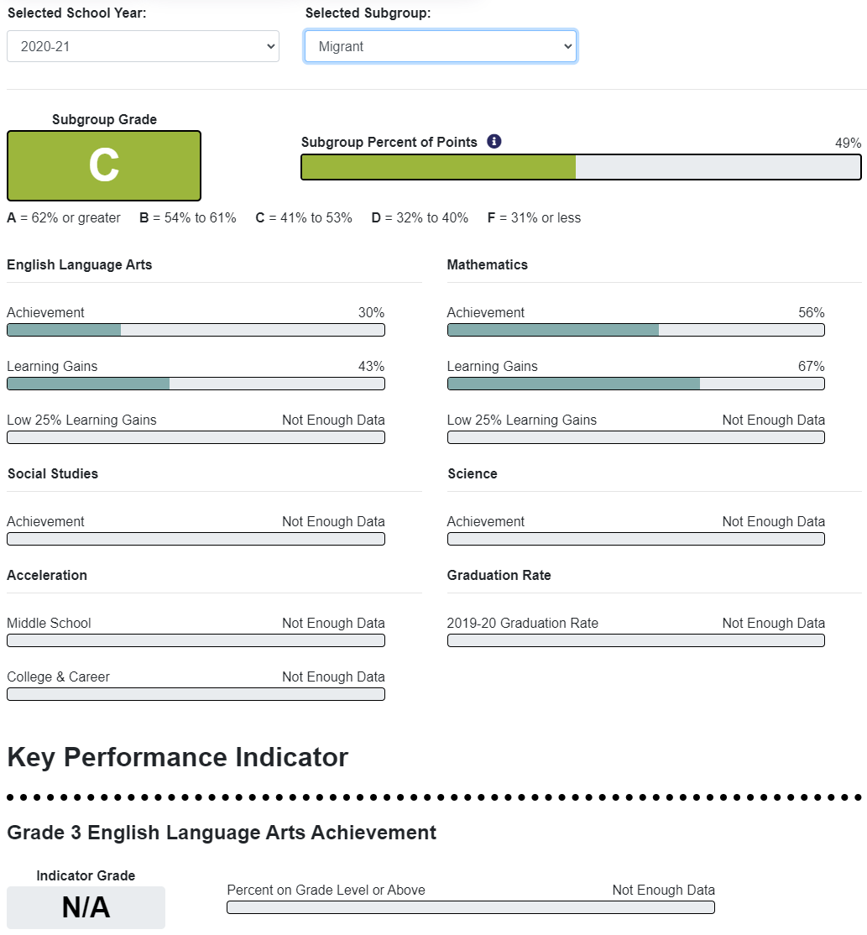
There is not enough data for other student categories

Interventions Utilized for Student Support:
Interventions will be small group and utilize supplemental curriculum to include Sonday System, DreamBox, Penda, Really Great Reading, iReady, Triumph Learning and Performance Coach along with other vetted curriculum based on student need. These curriculums can be adapted to support ELL, 504, ESE students as well as to enrich students. Progress monitoring will be kept through the district -wide MTSS process. While the majority of these interventions are face to face, there are some components that are web-based such as iReady having a web-based as well as workbook component. In such instances, both parts may be used if student need supports this.

Part III LEA Plan for Safe Return of In-Person Instruction

Each LEA developed and made publicly available on the LEA’s website a plan for the safe return of in-person learning in the Fall of 2020. This was before the enactment of the ARP Act. This plan must be updated to address the requirements of the U.S. Department of Education’s Interim Final Rule, 88 FR 21195. The Interim Final Rule “does not mandate that an LEA adopt the CDC guidance, but only requires that the LEA describe in its plan the extent to which it has adopted the key prevention and mitigation strategies identified in the guidance.” 88 FR at 21200. Any updated LEA plan must be consistent with state law, including any applicable executive order, any agency emergency order, or any agency regulation or rule. Note specifically that LEA policies must comply with section 381.00316, Florida Statutes, and that any policies implemented after August 9, 2021 must comply with Florida Department of Health Rule 64DER21 -12, F.A.C., and any policies implemented after September 22, 2021 must comply with Florida Department of Health Rule 64DER21-15, F.A.C.

Each LEA must seek public comment on the plan and take such comments into account prior to submission of the final plan to the Department within 60 days of the award. Upon the Department’s approval, the LEA shall post this updated plan on the LEA’s website within 90 days of the award.

☒ By checking this box, the LEA acknowledges the requirement that each LEA shall update its Plan for Safe Return of In-Person Instruction to reflect the requirements stated above, shall seek public comment on the updated plan and take such comments into account prior to the submission of the final plan to the Department within 60 days of the award. Upon the Department’s approval, the LEA shall post this updated plan on the LEA’s website within 90 days of the award.

Part IV: Assurances

The district must agree to ALL of the assurances by checking the corresponding boxes.

☒ Assurance 1: LEA Periodic Plan Update with Public Comment. As required in the U.S. Department of Education’s Interim Final Rule, 88 FR 21195, the LEA must regularly, but no less frequently than every six months, review and as appropriate, revise its plan for the safe return to in-person instruction and continuity of services. In determining whether revisions are necessary, and in making any revisions, the LEA must seek public input and take such input into account. If at the time the LEA revises its plan the CDC has updated its guidance on reopening schools, the revised plan must address the extent to which the LEA has adopted policies, and describe any policies, for each of the updated safety recommendations. Significantly, the Interim Final Rule “does not mandate that an LEA adopt the CDC guidance, but only requires that the LEA describe in its plan the extent to which it has adopted the key prevention and mitigation strategies identified in the guidance.” 88 FR at 21200. Any updated LEA plan must be consistent with state law, including any applicable executive order, any agency emergency order, or any agency regulation or rule. Specifically, LEA policies must comply with section 381.00316, Florida Statutes, and any policies implemented after August 9, 2021 must comply with Florida Department of Health Rule 64DER21 -12, F.A.C., and any policies implemented after September 22, 2021 must comply with Florida Department of Health Rule 64DER21-15, F.A.C.
☒ Assurance 2: Continue progress monitoring and interventions. The district agrees to provide robust progress monitoring and requisite interventions must be extended to all students with tiered support for students who are performing below grade level and are not making adequate progress. Students who are receiving instruction through innovative teaching methods must transition to another teaching method if they fail to make adequate progress. The district agrees to provide monthly progress monitoring reports to parent/guardians for students identified as performing below grade level and/or demonstrating decline on the district’s progress monitoring system.

☒ Assurance 3: Allowable Uses of Funds. The LEA will use funds for activities allowable under section 2001(e) of the CRRSA Act.

☒ Assurance 4: Maintenance of Equity. The LEA will comply with all requirements relating to Maintenance of Equity, in accordance with section 2004(c) of the ARP Act.

☒ Assurance 5: Reporting. The LEA will comply with all reporting requirements, and submit required reports to the Florida Department of Education at such time and in such manner and containing such information as the department may subsequently require.

☒ Assurance 6: Audits, Inspections or Examinations. The LEA will cooperate with any examination of records with respect to such funds by making records available for inspection, production, and examination, and authorized individuals available for interview and examination, upon the request of (i) the Florida Department of Education, the Florida Auditor General; (ii) the Department and/or its Inspector General; or (iii) any other federal or state agency, commission, or department in the lawful exercise of its jurisdiction and authority.

Acknowledgement

Local Educational Agency Chief Executive Officer or Authorized Representative

Name and title of person responsible for completion and submission
Dorota Micale – Director of Federal Programs
Contact information: email, phone number
micaled@mygcsd.org, 352-463-4408
Superintendent signature (or authorized representative)
